1. Extract the zip file
2. In Eclipse File -> Import -> Existing Maven Project

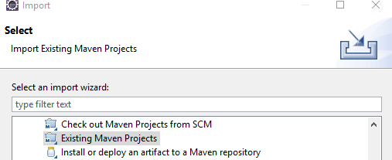

1. Select the folder You extracted
2. Your Project Structure Should Look like this

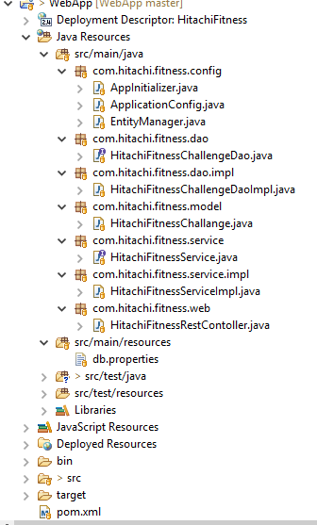

* If you run mvn clean install , all corresponding jars will be added, or you can manually add these jars to your classpath
* 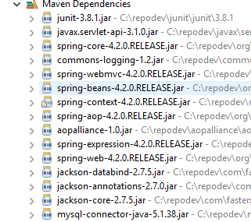

**Setting Up DB**

Run the below script to create database and required table in it



And this DML script after that to insert records



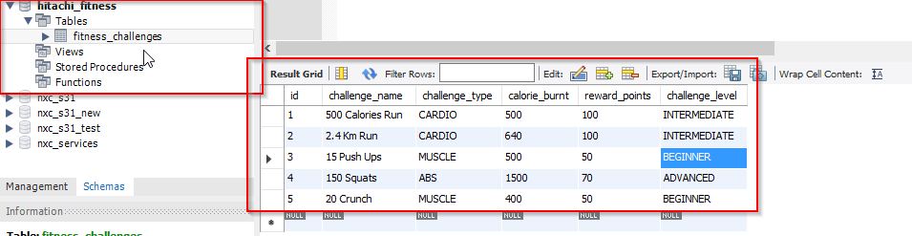

You can run the generated war elsewhere or you can run it by mvn tomcat7:run command

I tested these by postman, however test scripts can be written using mockito with junit

**Search API (** this can be enhanced to work on cached data instead of hitting DB, also another api can be developed to show suggestion while entering search value)

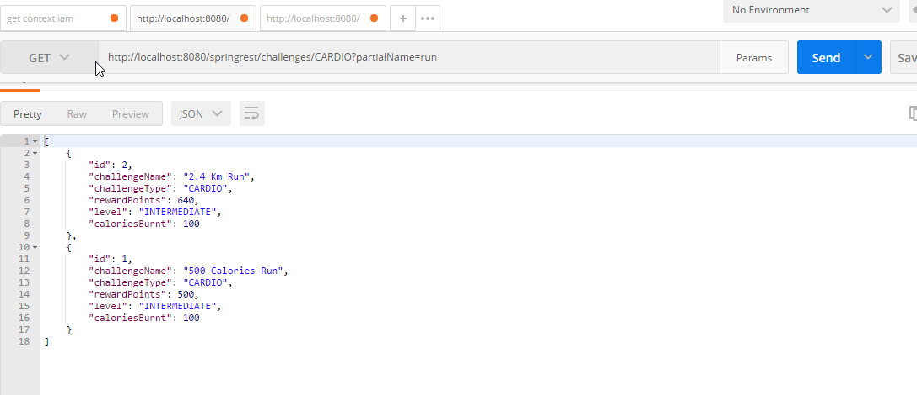

**Filter API**

